**ABSTRACT**

These years, with artificial intelligence and machine learning becoming the hotspot of research, several applications have emerged in each of these areas. It exists not only as a kind of academic frontier but also something close to our life. In this trend, the combination of medical care and machine learning becomes more and more tighter. The proposal of its main idea also greatly alleviated the existing situation of unbalanced medical distribution and resources strain. This paper summarizes some application of machine learning and auxiliary tumor treatment in the process of medical resource allocation, and puts forward some new methods of application to realize it closer to human life in the era of artificial intelligence and the explores a good situation of mutual combination of medical industry and computer industry, which is benefit both.

**EXISTING SYSTEM:**

In present systems there is hardly any medical service available in remote locations. Persons needing medical services often need to travel long distances. Even in urban areas the service is sometimes not available immediately. Patients and doctors are hardly to communicate with each others.And also patients had to wait for long time in order to communicate to the doctor.This main concern has to do with the confidentiality of the data. There is also concern about non-confidential data however such Systems that deal with these transfers are often referred to as Health Information Exchange.

**DISADVANTEGES:**

* Data Acquisition. **Machine Learning** requires massive data sets to train on, and these should be inclusive/unbiased, and of good quality. ...
* Time and Resources. ...
* Interpretation of Results. ...
* High error-susceptibility.

**PROPOSED SYSTEM**

In today’s society, medical care problems have become a hot topic, and problems such as the unbalance and insufficient allocation of medical resources has become increasingly apparent. In this situation, the application of ML has become the unavoidable trend in the current development of medical care. As early as 1972, the scientists in the University of Leeds in the UK has been trying to use artificial intelligence (ANN) algorithms to judge abdominal pain. Now, more and more researchers are committed to the combination of ML and medical care. The methods of pathological diagnosis of tumors, lung cancer, etc. by ML has gradually entered the field of vision. Some companies, such as Alibaba, Amazon, and Baidu have established their own research team working for it. This introduction of ML in medical care has greatly saved medical resources and provided a new way for citizens to see a doctor and facilitate people’s lives. At the same time, the demand of people also provides a new impetus for the research and development of ML, with promoting its continuous improvement.

**ADVANTEGES:**

* Identifying Diseases and Diagnosis. ...
* Drug Discovery and Manufacturing. ...
* Medical Imaging Diagnosis. ...
* Personalized Medicine. ...
* Machine Learning-based Behavioral Modification. ...
* Smart Health Records. ...
* Clinical Trial and Research. ...
* Crowdsourced Data Collection.

**SYSTEM ARCHITECTURE**

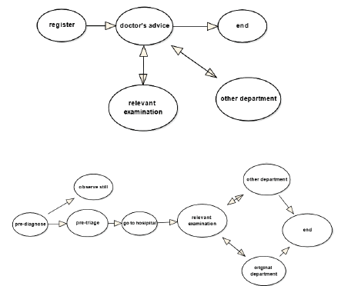

**SYSTEM SPECIFICATION:**

**HARDWARE REQUIREMENTS:**

* **System :** Pentium IV 2.4 GHz.
* **Hard Disk :** 40 GB.
* **Floppy Drive :** 1.44 Mb.
* **Monitor** : 14’ Colour Monitor.
* **Mouse :** Optical Mouse.
* **Ram :** 512 Mb.

**SOFTWARE REQUIREMENTS:**

* **Operating system :** Windows 7 Ultimate.
* **Coding Language :** Python.
* **Front-End :** Python.
* **Designing :** Html,css,javascript.
* **Data Base :** MySQL.

**REFERENCES**

[1] G. Eason, B. Noble, and I.N. Sneddon, “On certain integrals of Lipschitz-Hankel type involving products of Bessel functions,” Phil. Trans. Roy. Soc. London, vol. A247, pp. 529-551, April 1955. (*references*)

[2] Jiang M, Zhang S, Huang J, et al. Scalable histopathological image analysis via supervised hashing with multiple features[J]. Medical Image Analysis, 2016, 34:3-12.

[3] Joanna J K, Pawel K . Automatic Classification of Specific Melanocytic Lesions Using Artificial Intelligence[J]. BioMed Research International, 2016, 2016:1-17.

[4] Lu-Cheng, Zhu,Yun-Liang, Ye,Wen-Hua, Luo,Meng, Su,Hang-Ping, Wei,Xue-Bang, Zhang,Juan, Wei,Chang-Lin, Zou.A model to discriminate malignant from benign thyroid nodules using artificial neural network.[J].PloS one,2013,8(12):e82211.

[5] Huang W C , Chang C P . Automatic Nasal Tumor Detection by grey prediction and Fuzzy C-Means clustering[C]// IEEE International Conference on Systems. IEEE, 2006.M. Young, The Technical Writer’s Handbook. Mill Valley, CA: University Science, 1989.